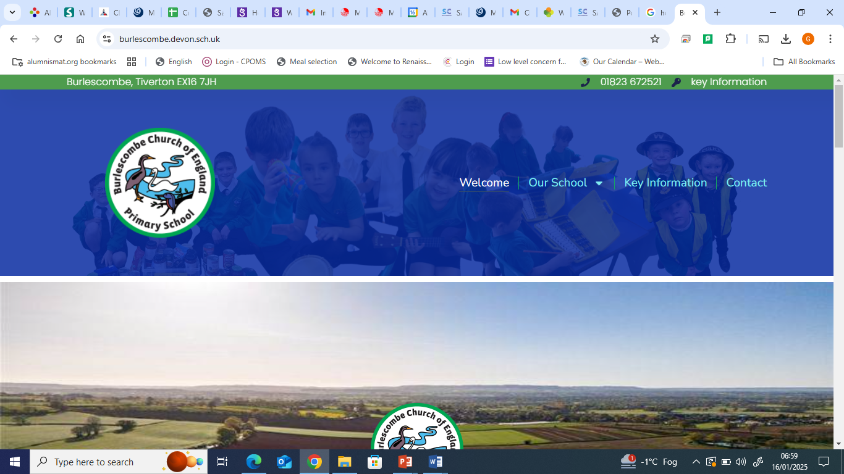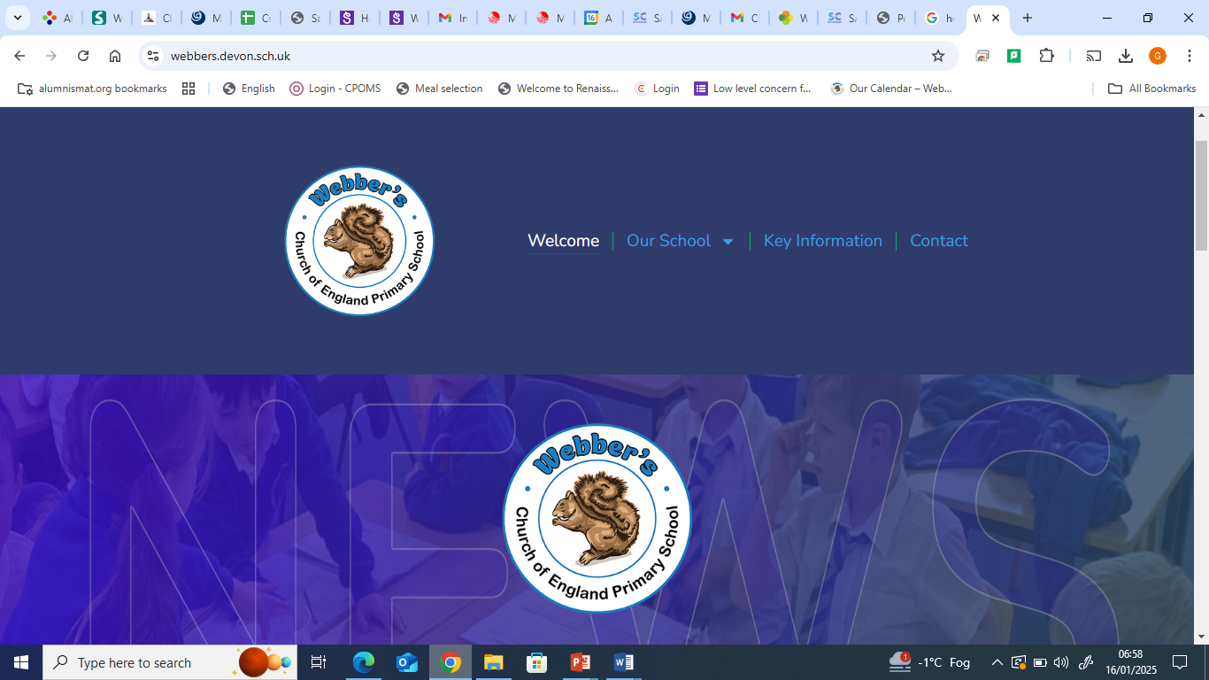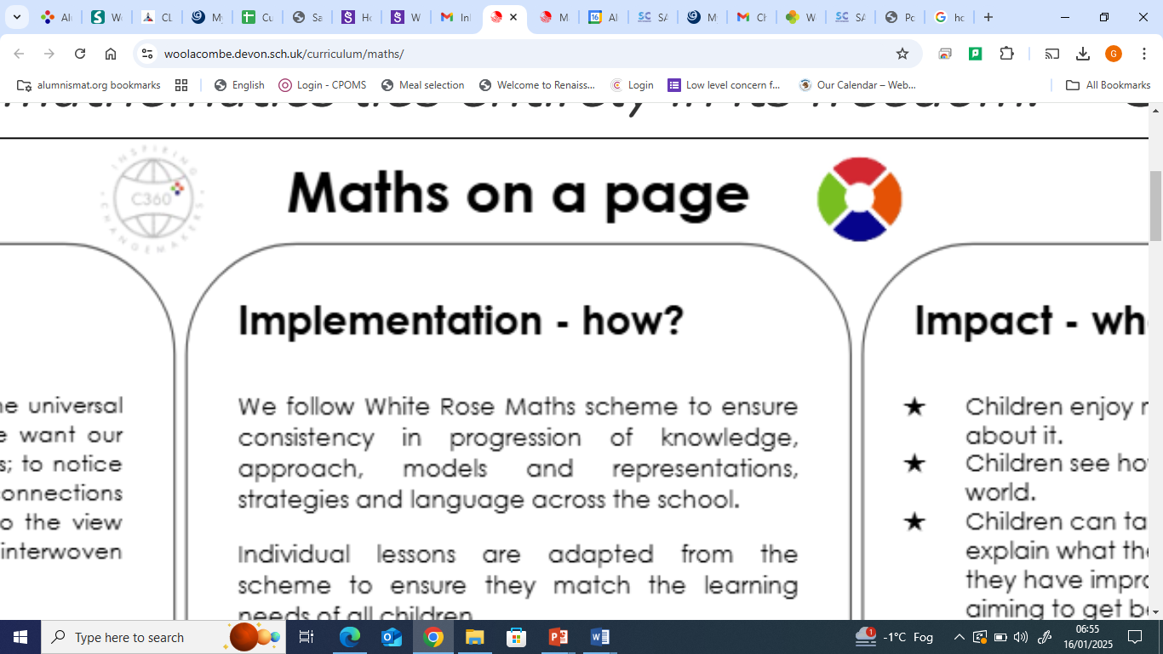

|  |  |  |
| --- | --- | --- |
| **Intent- Why?**  At Burlescombe and Webber’s C of E Primary Schools, we value maths and we want children to know that maths is essential to everyday life. We want to inspire our children to be confident mathematicians who are not afraid to take risks.  We provide opportunities for our children to experience the joy of maths; to notice and to actively seek out patterns. We provide children with a foundation for understanding number, reasoning, thinking logically and problem solving with resilience so that they are fully prepared for the future.  We aim for every child to achieve mathematical fluency, not just knowing facts, but knowing how to derive them using their conceptual knowledge. It is intended that children leave Webber’s and Burlescombe Primary Schools with an appreciation and enthusiasm for Maths, resulting in a lifelong positive relationship with number.  Regardless of their starting point, we intend to maximise their academic achievement and we work towards all children becoming logical problem solvers, approaching their work systematically, using their prior knowledge as the starting block from which to go forward. We will encourage resilience through success and productive struggle as they find solutions to problems, seeking help when needed but ultimately aiming to become independent problem solvers.  We strive for all children to become proud and confident mathematical speakers, articulating their own thinking clearly and concisely. They will learn to challenge their ideas respectfully and help to improve on the ideas of others. | ***Implementation- How?***   * *Mathematics is taught on a daily basis throughout the school – EYFS to Year 6. Each class in KS1 and KS2 provide a minimum of 1 hour of mathematics per day. A mix of adult led and teacher led activities are put together for children in EYFS.* * *The use of White Rose medium term planning is adapted to create a bespoke curriculum designed to meet the needs of our children and to allow for opportunities for revisit and retention, ensuring full coverage of the national curriculum for mathematics and providing a broad and balanced spread of all areas of the curriculum. Teachers are confident to manipulate this planning in the short term in order to meet the needs of all of our children.* * *Using the school’s progression of skills document, the teaching of mathematics year to year builds progressively on the skills taught in previous year groups.* * *On a daily basis, children, regardless of their ability, in KS1 and KS2 are provided with opportunities to become more fluent in their learning, to reason mathematically and to solve a range of problems.* * *We use Times Table Rock Stars- and regular assessment in KS2- to enthuse the children in learning times tables and evidence their progress in doing so.* * *Mathematics homework is provided on a weekly basis to help embed the week’s learning and share the learning with parents/carers through our online platform.* * *Calculation practice is provided regularly through basic skills starter activities to ensure children’s fluency in calculation methods is embedded.* * *Learning is differentiated to meet the needs of the children within the class whilst still providing each child with the opportunity to achieve the learning intentions to meet the expectations of their year group.* * *Opportunities to collaborate in pairs or small groups are given regularly so children can learn from and support each other.* * *Quality first teaching is provided throughout the school along with effective teacher modelling along with effective assessment for learning to make sure children are moved on in their learning or supported when finding it difficult* * *Cross-curricular links are provided when opportunities arise, particularly through the use of Computing.* * *Mathematics 'working walls' are in each classroom to provide key information and vocabulary with modelled examples to support learning.* | **Impact- what?**  As a result of our Quality First Maths teaching in Burlsecombe and Webber’s Primary Schools, you will see:   * Children who enjoy maths and display curiosity about it * Engaged children who are all challenged regardless of their ability. * Children who can use their previous knowledge to support their ongoing learning. * Children who are able to reflect on mistakes and use these to support further learning. * Confident children who can all talk about Maths and their learning and the links between Mathematical topics. * Enthusiastic children who can discuss the importance of maths in the wider world and the impact that this has on their daily learning. * Lessons that use a variety of resources to support learning. * Different representations of mathematical concepts. * Learning that is tracked and monitored to ensure all children make good progress. |